Task Report

Decrypting Data in Linux
In this scenario we must decrypt encrypted data. While working with private information as a Cybersecurity Analyst, decrypting data is part of ensuring that your organization has access to pertinent information.

Task 1.
First, within our current working directory, we discover the files it holds

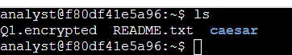

Command Semantics
    - ls This command provides a list of files contained in the current working directory
          - NOTE – in conjunction with the ls command you can use commands such as l and a to list hidden files and additional information about the files, respectively.

Task 2.
In this step we attempt to discover the information found within the README.txt file that we discovered using the ls command.

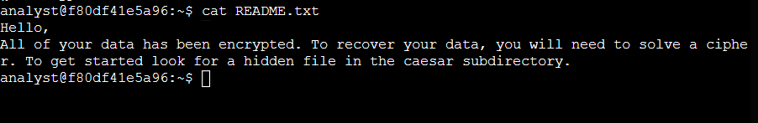

Command Semantics
    - cat this command accesses the text in the file.
    - cat <file>

Task 3.
Navigate to the “caesar” directory

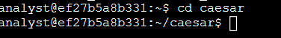

Command Semantics
    - cd caesar This command changes directories, in this case, from the “analyst” directory to the “caesar” directory

Task 4.
Discover the contents of the “caesar” directory

Command Semantics
    - ls -a This command lists the files and hidden files in the Directory.
      - ls Lists the files.
      - -a Discovers the hidden files

Task 5.
Discover the contents of the .leftShift3 file

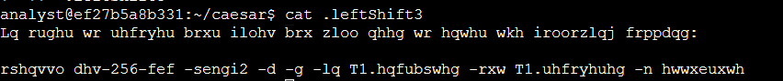

Command Semantics
    - cat .leftShift3 the cat command opens the text contents of the file
      - Note – the contents of the files are in Ciphertext.

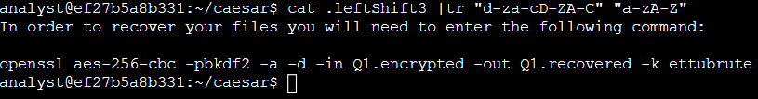

    - cat .leftShift3 | tr “d-za-cD-ZA-C” “a-zA-Z”
      - the command to the left side of the pipe ( | ) remains the same,
      - the pipe ( | ) sends the results of the first command into the command on the right side of the pipe ( | ).
      - I do not fully understand yet the command to the right of the pipe – it was provided in the lab. Here is what I do know – the tr command is a deciphering command while the commands within the quotations are instructions on how to translate the text. Furthermore, I can also provide the understanding that hot wings are delicious.

Task 6.
The previous task gave us information we need to decipher the text in a file we are working with. Seeing that the file is in our home directory and we are currently in the “caesar” directory, we need to navigate to the “home” directory.

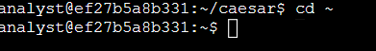

Command Semantics
    - cd ~ the cd command changes directories. The ~ indicates to the computer that we are to be in the “home” directory.

Task 7.
Decrypt a file using the information that was previously deciphered

While I do not completely understand this command either here is an overview of what it does.
    - The command takes the encrypted data from the file after the -in command and makes a new file with the new name commanded after the -out command
    - The command indicates the various attributes of the encryption such as the algorithm to be used to solve the encryption etc.

Command Semantics
    - openssl aes-256-cbc -pbkdf2 -a -d -in Q1.encrypted -out Q1.recovered -k ettubrute the following is mostly a copy and paste from the lab's explanation of the attributes of this commands
      - openssl command reverses the encryption of the file with a secure symmetric cipher.
      - AES-256-CBC indicates the Symmetric cypher to be used.
      - -pbkdf2 option is used to add extra security to the key
      - -a indicates the desired encoding for the output.
      - -d indicates decrypting
      - -in specifies the input file
      - -out specifies the output file
      - -k specifies the password
      - ettubrute the password

Task 8.
Now we discover the file and read the file that has been provided by our decryption command

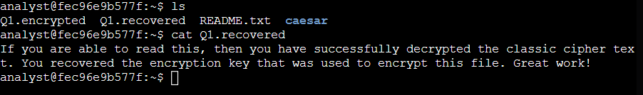

Command Semantics
    - ls this command lists the files and directories in the current working directory.
    - cat Q1.recovered this command provides us with the contents of the Q1.recovered file that the decryption command provided.
    - cat <file>

Summary
In this lab we navigate the fhs to find various files and directories needed to decrypt the contents of a file. In the end, we got an adda boy from the recovered or decrypted file. Is it possible that hot wings can be delivered digitally yet?

